NELP-Commons, LLC d/b/a The Commons in Lincoln [AL/ALZ] is certified by the Massachusetts Executive Office of Aging & Independence to be the Sponsor of this Assisted Living Residence.
In this Disclosure of Rights and Services (“Disclosure Statement”), The Commons in Lincoln [AL/ALZ] is called “the Community” or “we.” This Community is managed by Benchmark Senior Living LLC.
In accordance with the Massachusetts Assisted Living regulations 651 CMR 12.08, the Sponsor of an Assisted Living Residence is required to convey information and deliver and review specific documents prior to the execution of the Residency Agreement or the transfer of any money to the Sponsor by or on behalf of a prospective Resident.
Your signature and initials below, confirm that each required disclosure has been met accordingly. YOUR INITIALS
- Prior to scheduling a formal meeting with the Assisted Living Residence, you were informed of your right to be accompanied by a Legal Representative (Guardian, Conservator or power of attorney); or by any Resident Representative or other advisor of your choice, such as a family member, authorized by you to help you plan for care and services. X_____
- You have received a hard copy and verbal review of this “Disclosure of Rights and Services” prior to signing any Residency Agreement or making any payments. X_____

- You have received a hard copy and verbal review of “Assisted Living in Massachusetts: A Consumer’s Guide” prior to signing any Residency Agreement or making any payments. X_____
Please sign below. We will retain one copy and one copy will be given to you.
SIGNATURE OF RESIDENT or RESIDENT’S LEGAL REPRESENTATIVE
Name: Insert Name Date: Click or tap to enter a date.
Signature: ___________________________
Or
Electronic Signature: Click here to enter text.

☐ (check if applicable) I have agreed to sign this form by electronic means. I understand and intend that my electronic signature have the same legal effect as a written signature.
PART A. This Part of the Disclosure Statement contains information that applies specifically to this Community. General information that applies to all assisted living communities managed by Benchmark Senior Living in this State can be found in Part B.
I. We are certified to operate the following number of Traditional Living/Assisted Living units:
_____ Assisted Living Units

We are certified to operate the following number of Harbor Program/Special Care units:
_____ Units in _____ Special Care Residence(s) (“SCR”)

II. Staffing
Our staffing is determined by the then-current occupancy and the amount of care our residents require.
If applicable, in our Traditional Living/Assisted Living setting, on average, we currently employ awake staff in no less than the following numbers:
Shift Description | # of Resident Care Associates (RCAs) | Shift Description | # of Licensed Nurses
7:00AM – 3:00PM | ____ RCA(s) | 7:00AM – 3:00PM | ____ licensed nurse(s)
3:00PM – 11:00PM | ____ RCA(s) | 3:00PM – 10:00PM | ____ licensed nurse(s)
11:00PM – 7:00AM | ____ RCA(s) | 10:00PM – 7:00AM | ____ on-call nurse(s)

If applicable, in our Harbor Program/Special Care setting, we employ, on average, staff as described in the next chart. We staff a minimum of two awake employees in the Harbor at all times.
Shift Description | # of Resident Care Associates (RCAs) | Shift Description | # of Licensed Nurses
7:00AM – 3:00PM | ____ RCA(s) | 7:00AM – 3:00PM | ____ licensed nurse(s)
3:00PM – 11:00PM | ____ RCA(s) | 3:00PM – 10:00PM | ____ licensed nurse(s)
11:00PM – 7:00AM | ____ RCA(s) | 10:00PM – 7:00AM | ____ on-call nurse(s)
In Traditional Assisted Living or Harbor, the number of employees may vary from time to time (i.e. attendance in necessary meetings held outside out of the Community; holidays; resident assessments conducted away from the Community; any extenuating circumstances affecting staff availability such as staff illness, unexpected call-outs, shortage of qualified staff, turn-over of staff, etc.); however, every effort is made to maintain consistent staffing patterns in accordance with residents’ needs.

III. Physical Design Features of the Community.
____ # of floors
____ # of living room(s)
____ # of activity room(s)
☐ Secure Special Care Residence(s) (“Harbor”) located on the ____ floor
☐ Harbor Courtyard
☐ Library
☐ Dining Room
☐ Family/Country Kitchen
☐ Bistro
☐ Outdoor patio/seating area
☐ Multi-purpose room
The stairwells in some of our Branches communities (North Attleboro, Marlboro and Framingham) are emergency egress exits which may be locked for safety purposes. Stairwells are accessible in the event of an emergency or should the elevator be rendered out of use for any reason. Note that the front doors in our communities are secured from 8 p.m. to 8 a.m., and residents have access to leave at any time after 8 p.m. by alerting staff. If a resident wishes to have a fob to the Community’s front doors for the purpose of entering and exiting the community after 8 p.m., the resident may make this request in writing to the Community’s Executive Director.

IV. Activities
We provide a minimum of 6 hours of enrichment and recreational activities each day, including for example, exercise, spiritual activities, arts & crafts, social hour, manicures, musicians, book club, gardening, games, transportation, shopping, painting, tai chi, yoga, cooking & baking, lectures, and computer classes. A copy of the activities calendar is posted in the community.
We may also occasionally host activities which are open to the general public, such as small seminars or programs affiliated with local associations or clubs. Specific details, such as when these activities occur and what rooms are affected, will be announced to residents in advance. These activities do not have any impact on staffing for resident hospitality or care.
Insert any regularly scheduled non-resident use at this community. [Examples: The community hosts the local Alzheimer’s Association chapter on a monthly basis. The local boy scout troop uses our multipurpose room every other Saturday morning] (and insert if applicable) This This Community hosts a Harbor Respite-by-Day Program, where we invite a limited number of participants from the external community to join in activities and meals along with Harbor residents, in order to introduce them to life in an assisted living/memory care community. Participants in the Respite-by-Day Program must complete the same assessment process that the Community requires for Harbor residents. As noted earlier, our Community’s staffing is determined by occupancy and the amount of care required by our residents, which also includes the needs of any Respite-by-Day participant, for days when a Community hosts the program.

V. Financial Assistance Programs
This Community ☐does not participate in government-sponsored or other financial assistance programs.

☐participates in government sponsored or other financial assistance programs. See the “Financial Assistance Addendum” to this Disclosure Statement.

☐GAFC

☐LIHTC

☐Community-specific program

PART B.
This Part of the Disclosure Statement contains general information that applies to all assisted living residences managed by Benchmark Senior Living in this State.

- Medication Management Programs
The resident or his or her family is responsible for coordination of medications with the pharmacy. The pharmacy selected by the resident maintains complete responsibility for proper filling of prescriptions and medication cassettes per physician orders. Depending on the pharmacy you choose, either the pharmacy or the resident or his or her family is responsible for delivery of medications to the suite per physician orders. The Community does not pick up medications for residents at the pharmacy.
All medications must be stored securely in your suite at all times. A refrigerator will be provided for medication storage, if needed. All medication containers must clearly identify your name and the date.
A word about medications that are to be taken “as necessary” (often called PRN medications): If you are participating in our medication management programs described below, the Community can assist you with PRN medications, if you let us know any time when you feel that you need to take that medication. If the medication can be self-administered, our aide will assist you. If however, your medication requires administration by a nurse, a nurse is available to assist you with your needs during regular nursing hours and arrangements are made with our “on call” nurse at any other time.

- Self- Administered Medication Management
Self-administered medication management (SAMM) is a program in which we are able to assist you with prescription, over-the-counter and PRN (“as needed,” when requested by resident) medications by: (1) reminding you to take your medication; (2) checking the package to ensure that the name on the package is your name; (3) if requested by you, open pre-packaged medication and/or open containers; (4) observe you while you take your medication; and (5) document in writing our observation of your action regarding the medication. At our Community, this service is provided by a resident care associate known as a medication aide who has completed specialized training and receives competency testing every six months in accordance with state regulation.

SAMM is available only for our residents who have been assessed as being able to self- administer medications safely.
Family Filled Cassettes: We support a family’s right to use a pharmacy of their choice and/or to provide for family-filled medication cassettes. All residents who participate in SAMM are eligible to participate in the family-filled cassette procedure, although in the interest of our residents’ health and safety, we strongly suggest our residents choose a pharmacy that will pre-package and deliver their medications directly to them. Our nurse can provide the family with the contact information for a local pharmacy that pre-packages medications and delivers them to the resident in a timely and consistent manner.

The Community will allow for family-filled medication cassettes under the following conditions:
- You or your responsible party signs a written consent and Negotiated Risk Agreement acknowledging your understanding and acceptance of the potential risks associated with family-filled cassettes;
- You or your responsible party agrees to keep the Community up-to-date with medication changes;
- You or your responsible party chooses a pharmacy that is reliable and able to deliver medications to your unit in a Community-approved cassette in a timely manner;
- You or your responsible party orders / reorders all medication and removes all medications discontinued by the physician;
- You or your responsible party keeps all medications secure within your unit, using the provided medication safe. Inside the safe, there is a secondary locking mechanism for controlled substances. If medication storage requires a refrigerator one will be provided by the Community; and
- All medication containers must be labeled with the resident’s name and date.
The Community maintains the right to rescind your right to family-filled cassettes if at any time, it is the Community’s assessment that your family is unreliable with the delivery and containment of medications as prescribed by your physician and defined by the Community.

B. Limited Medication Administration
Limited Medication Administration (LMA) is available for residents who are assessed as needing greater assistance with medication management. Under LMA, a licensed nurse will administer your non-injectable medications that are permitted to be administered by one of our Community nurses under applicable regulations, such as oral medications, eye drops, inhalers and topical medications, as frequently as you require in accordance with your physicians’ orders. This medication management service is available during the established regular nurse hours at the Community seven days per week.
When providing LMA, the Community assists in coordination with the pharmacy to ensure availability of medication. This program includes coordinating new physician orders to the pharmacy as well as reordering of medication when needed. The pharmacy selected by the resident maintains complete responsibility for proper filling of prescriptions per physician orders. Depending on the pharmacy you choose and subject to the important limitations below, either the pharmacy or the resident or his or her family is responsible for delivery of medications to the suite per physician orders. The Community does not pick up medications for residents at the pharmacy as part of this service.
We support a family’s right to use a pharmacy of their choice; however, for the health and safety of our residents, we strongly recommend that residents on our LMA program choose a pharmacy using the Community’s approved medication packaging system.
For the safety of our residents, and to ensure the integrity of their medications, we require residents who do not use our preferred medication packaging system (for example, if a family member obtains medications from a mail order service) to have medications delivered directly from the pharmacy to the resident. This would include hand delivery by a local pharmacy or mail order delivery directly to the resident. We understand that in some cases, mail order pharmacies will not deliver certain categories of medications. For example, in our experience, mail order pharmacies for residents with Veterans’ benefits will not provide the following medications:
  - over-the-counter medications (note that these must always be in original pharmacy-filled containers);
  - controlled substances such as narcotics; and
  - urgent care or other short-time or one-time medications, such as antibiotics.

For these medications (as well as any others that the pharmacy chosen by the family will not deliver), the Community will maintain a list of local pharmacies that will deliver medications directly to the resident. Unless there are no local pharmacies that will deliver medications or unless the pharmacy will not deliver the applicable medication, the resident and his/her family will be required to use one of these pharmacies, except in an emergency. Only in an emergency or if a local pharmacy is not willing or able to deliver the prescription directly to the resident, the family may obtain the prescription from a local pharmacy and hand deliver the prescription to the Community. Please note that for residents on LMA, all over–the–counter medications must in all cases be delivered in pharmacy-filled containers with the residents’ name, date and dosage information on the label.

* * * *
We strongly suggest you choose a pharmacy that will pre-package your medications and deliver them directly to you. The nurse may provide you with a local pharmacy that pre-packages medications and delivers them to the Community in a timely and consistent manner. The Community is not responsible for the performance of the pharmacy recommended.
- Explanation of Limitations on Services.
All service limitations listed below should be discussed with the Community Executive Director or Resident Care Director, as there may be opportunities to coordinate supplemental care within the Community with the use of our Benchmark Signature Services resident care associates or other appropriate outside service providers, or the provision of short-term solutions through special programming.
If the need arises for a secure environment with specialized care and programming, our Harbor Program provides such services for residents with cognitive or memory limitations. If this need arises after move-in, a resident may be required to move to the Harbor Program (if available).

Except as otherwise expressly stated in this Disclosure Statement, the Community does not provide the following services:
- Behavioral management services when a resident presents a safety risk to self or others; or
- Support for a communicable disease that cannot be safely contained or managed in the resident’s suite;
- Skilled nursing services, including but not limited to assisting with or administering injectable medications, feeding tubes, assistance with or management of catheter systems, sterile dressing changes, decubitus care, management of or care for ostomy sites, titration of oxygen, and management of or care for complex and unstable physical or mental conditions, except as permitted in each case by applicable regulations. Many of these skilled nursing services can be provided by a home health agency in your suite; or
- Assistance with Schedule I Controlled Substances.
In addition, a resident’s needs may exceed the level of services we provide through our Traditional Level V Program or Harbor Level V Program (see Residency Agreement - Attachment A). These plans do not include one-to-one companionship or supervision. There may also be situations in which a resident’s total care needs exceed our Personal Service Programs.
As noted above, if your needs exceed the services we provide, it may be possible to accommodate your needs by supplementing our care with either appropriate third party service providers or, as permitted by applicable regulations, our Benchmark Signature Services resident care associates. Please see the section entitled “Benchmark Signature Services” in the Residency Agreement.
If your needs exceed the care we provide, and it appears that the needs cannot be accommodated safely by supplementing our care, we will work collaboratively with you, your legal representative and healthcare provider when the changes in your service needs occur and discuss other options.

- The Role of the Nurse.
The role of the Community’s nurse is to provide wellness services as permitted under law, as well as services authorized or required under the assisted living regulations. More specifically, the nurse is responsible for the following:
- Assessing your service needs and preferences and coordinating the development of your service program.
- Assisting with orientation and in-service education training of all staff;
- Administering non-injectable medications when Limited Medication Administration is needed to residents under the Traditional Level II or Level III or the Harbor Medication Management Packages during regularly scheduled nurse hours;
- Providing 20 hours of personal care training for employees providing personal care who have not completed one of the following state-recognized training programs: RN, LPN, CNA, HHA, homemaker/personal care homemaker;
- Providing an introductory visit: review each resident’s service program with all personal care workers (including any Benchmark resident care associates) who shall be providing personal care services to the resident. This introductory visit shall be completed prior to or within 48 hours after a personal care worker is to provide personal care services to a resident;
- Providing supervision of Resident Care Associates: evaluation of personal care services provided by personal care staff of the Assisted Living Community or by a contracted provider will take place at least twice per year and will include evaluation of performance of personal care skills; and
- Assisting you and/or your representative in arranging for the provision of ancillary health services in the Community.
The nurse will not provide nor direct any non-licensed staff to perform skilled/clinical nursing care, per state regulations. Such clinical nursing care includes, but is not limited to, assistance with and/or administration of injectable medications, feeding tubes or sterile dressing changes.

- Move-in Criteria; The Resident Assessment Process.
Our decision about whether the Community and the services it offers are appropriate for you will be based on your health and functional status.
You will need to provide a physician’s statement about your current health status; we require this statement to be written on a form we provide to you. Upon our request, you also agree to provide the results of a PPD or chest x-ray performed within thirty (30) days of the date you begin to reside at the Community. Our licensed nurse also will assess your health status and functional abilities, before a decision is made.
Admissions decisions are based on information obtained from your physician and on this assessment. Generally, admissions decisions are based on whether the services we provide can meet your needs.
There are certain circumstances where we cannot meet your needs (for example, dangerous behaviors, communicable disease that cannot be safely contained). There are other situations where your needs may exceed the level of services we provide under our Personal Service Programs. In these cases, arrangements can be made to meet your needs through appropriate third party service providers or our Benchmark Signature Services resident care associates. For a more detailed discussion, please see Section II. (“Limitations on Services”) above.

- Cardiopulmonary Resuscitation (CPR).
Some of our staff are CPR-qualified and may administer CPR if they are at the scene when an emergency requiring CPR occurs. At least one staff member who is CPR qualified will be on duty for each shift. At the same time, in this residential setting, it is not possible to guarantee that an appropriately trained and qualified staff member will be immediately available to administer life support services. You are asked to notify the Resident Care Director if you do not want CPR administered in an emergency. Your physician must give us an order to withhold CPR. Our policy is to honor your wishes as to whether you want CPR administered, as long as you have provided us the appropriate written instructions and an order has been provided by your physician.

- Termination of Residency Agreement.
A resident (or resident’s Legal Representative) may terminate the Residency Agreement at any time, with or without a reason, by giving us written notice (which includes the move out/termination date), at least 30 days in advance of the date when the residency is to end. In the event of the death of a resident, the Residency Agreement terminates 30 days after the date when the Community is notified of the death.
If we terminate the Residency Agreement, the resident cannot be evicted except in accordance with the provisions of the State’s landlord/tenant law as established by M.G.L. c. 186 or M.G.L. c. 239 including, but not limited to, an eviction notice and utilization of such court proceedings as are required by law. Reasons for termination of the Residency Agreement include failure to make payments as required in the agreement; failure or refusal to comply with rules and policies in the Resident Handbook, Harbor Family Handbook, or the Residency Agreement; a material misstatement, omission or misrepresentation in the residency application; a resident has become a danger to self or others, and is no longer able to reside safely in the Community; or closure of the Community. The resident is entitled to fourteen (14) days’ written notice if the Agreement is being terminated for nonpayment of fees. For any other breach of the Residency Agreement, the Community will provide at least 7 days’ written notice, except in an emergency when there is a serious risk of harm to the resident or to other residents.

- Your Service Program.
We will develop your service program with you and your Legal Representative, with your permission. If a Guardian of the Person has been appointed by the court, he or she will also be asked and encouraged to participate.
If you notify us that you would like any other person – for example, your health care representative, a relative or friend – to be involved in discussions about your service program, that person will be included in such discussions.
Your initial individual service program is developed by our licensed nurse with you and/or your representative and/or your authorized practitioner prior to your move to the Community, based upon our initial assessment of your needs. You and/or your representative and we sign and date your initial service program. We will conduct a reassessment thirty (30) days after you move to the community, if you request a service need change, or whenever a significant change in your condition warrants, but no less frequently than once every six months. A reassessment may result in changes in your individual service program. You will work with us in developing and carrying out an individual service program that meets your needs and preferences, including changes in your needs and preferences.
Your individual service program lists specific services you will receive (such as activities of daily living and assistance with medication management), their frequency and identification of the providers of such services. Charges are set forth in the Fee Schedule attached to the Residency Agreement. Please note that a reassessment of your personal care needs may result in a change in your individual service program and therefore a change in fees. A sample of an individual service program is attached to this Disclosure Statement.

- Special Diets.
Three meals are served daily. All of our standard menu choices are prepared with no added salt and reduced sodium in the cooking. Available special diets include no concentrated sweets and low fat.
While we will attempt to accommodate residents’ needs, the Community kitchen is not a gluten free or nut product free environment. You must note any food allergies as part of your initial (or any subsequent) assessment which will then be communicated to the Dining Services Director on the Diet Notification Form.
Texture-modified diets (chopped, mechanical soft and puree) are available in this Community with a physician’s order. Note that our community staff is not permitted to thicken liquids with powdered products or to otherwise thicken liquids; however, we will provide pre-packaged, pre-thickened liquids to a resident based on physician’s orders for an additional charge.
Staff will encourage each resident to make appropriate food choices. We encourage family and friends to honor any special dietary needs the resident may have when bringing food to the Community.

VIII. Special Care Mission Statement and Philosophy.
Our Harbor Program provides special care and specialized programming for residents with Alzheimer’s disease or other dementias.
In the Harbor Program, we create an environment for our memory-impaired residents that promotes a sense of autonomy and choice, love and belonging, self-esteem and the ability to make a contribution. We understand that each resident is unique with a lifetime of experiences and memories that remain accessible and can be shared and understood.
Each resident is entitled to live a life with dignity, and to have a sense of trust in and control over his or her environment. We relate to the person, not to the disease or its symptoms. We understand that basic human needs are the same for everyone, including people with dementia. Every resident is treated with respect.
We implement this philosophy by special training for Harbor caregivers and other employees in the care of residents with dementia and with special staffing ratios for the Harbor program.
The physical environment is designed to enhance the way in which Harbor residents experience their daily lives and to provide a safe, homelike environment that promotes privacy and orientation while encouraging socialization.
Cultural, social, recreational, spiritual and wellness programs are available to residents both on-site and through group trips. Activities are specially designed to meet residents’ needs. Our goal is to maintain residents’ contentment by providing failure-free programming throughout the day.
Family involvement in resident activities and mealtimes as well as in service planning is encouraged. Educational programs for family are also provided.

- Grievances, Complaints and Concerns.
You and your family are encouraged to bring any complaints or concerns that you may have to our attention immediately. Expressing a complaint or concern will not affect the services or care we provide to you in any way. If the particular associate you speak to is not able to answer or address your issue, the associate will refer the problem to someone at the Community who can and will respond promptly. If you do not want to speak directly to a staff member or if you are not satisfied with a staff member’s response, we encourage you to meet with the Community’s Executive Director.
In addition, problems and complaints can be brought to the attention of the Residents’ Association or you may use one of the confidential suggestion boxes at the Community. We will respond promptly to issues brought to our attention in these ways.
If you are not satisfied with our response, or if you believe that expressing your complaint or concern within the Community will not be productive, you may contact Benchmark Senior Living at the address provided in the Residency Agreement. You may also contact the Assisted Living Ombudsman at any time to arrange for the confidential submission of your grievance. Their contact information is as follows:
Assisted Living Ombudsman
Executive Office of Health and Human Services
One Ashburton Place, 5th Floor, Room 517
Boston, MA 02108
617-222-7495

- Rules of Conduct for Staff and Residents.
Some specific rules that we require residents to follow for the comfort and well-being of all residents are found in the Resident Handbook or Harbor Family Handbook. Residents must conduct themselves in a way that is considerate and respectful of other residents. No part of the Community may be used for any illegal purpose or in any improper or offensive way. Copies of the Resident and Harbor Family Handbooks are available upon request.
Firearms are not permitted in your suite or anywhere in the Community. The Community’s policy on smoking is included in the Resident or Family Handbook.
We expect all of our associates to be courteous, pleasant, respectful of residents, families and other staff, and appropriately trained for the jobs they perform. We have rules of conduct for all associates that strictly prohibit inappropriate behavior; for example:
- Abuse or neglect.
- Deliberate or careless destruction, damage or theft of property.
- Possessing firearms or being under the influence of alcohol or controlled substances while at work.
- Soliciting or distributing any material in violation of company policies.
- Failure to keep resident information confidential as required by law.

- Security and Guest Policies
Visitors have the capability to visit 24 hours a day. From 8 a.m. to 8 p.m. our front lobby is open to the public and guests are required to sign in at the front desk with our reception staff. After hours, any visitors will need to be let in by our evening and overnight staff as the community is fully secure.

- Bed Rails.
It is a resident’s right to be free from physical restraints, which may include bed rails. Bed rails have been found, in some cases, to increase the incidence of falls or head trauma due to falls and other accidents such as strangulation and entrapment. Bed rails include all rails or bars that run partially or fully along one or both sides of a resident’s bed, including “u-bars” and similar devices. Alternatives to bed rails include grab poles, body pillows and beach flotation devices. If you believe that you or your loved one has a higher risk of falling or may require assistance with mobility getting in or out of a bed, such that a bar or rail might help, you must regularly have an assessment to determine your ability to navigate independently around a bed rail and safely get in and out of bed. This assessment must be performed by a physical or occupational therapist. The Community can assist you with arrangements for such an assessment which will be performed for a fee charged to you separately by the therapy company. A copy of the assessment will be kept in your wellness file.

XIII. Response to Urgent or Emergency Needs.
The Community provides residents with emergency response devices such as pull cords or pendants. The emergency response system is backed by sufficient staffing at all times to respond promptly and effectively to individual resident emergencies.
Harbor Residents: As personal emergency response devices may not be practical for Harbor residents, hourly visual checks of residents are performed nightly between 7 p.m. and 7 a.m. If an individualized assessment reveals that hourly checks may not be appropriate for a resident, an alternate approach will be determined.

XIV. End of Life Options.
Information is available to you regarding health care decision-making and various options for care at end-of-life, including hospice and palliative care which can be provided to residents within the Community. We will offer to provide such information to you if appropriate, or upon request to the Executive Director or Resident Care Director.

XV. Emergency Instructions.
In the event of an emergency situation that affects the Community generally (for example, a power outage, flood or other emergency or disaster), staff will instruct residents appropriately.
* * * * * *
EMERGENCY INSTRUCTIONS TO RESIDENTS
IN CASE OF AN EMERGENCY SUCH AS A POWER OUTAGE, FLOOD OR FIRE, STAY WHERE YOU ARE! STAFF WILL GIVE YOU DIRECTIONS APPROPRIATE FOR THE EMERGENCY SITUATION.

If you wish to review a copy of the Community’s Disaster and Emergency Preparedness Plan, please contact the Executive Director.

XVI. Resident Rights
RESIDENT RIGHTS IN
MASSACHUSETTS
651 CMR 12.08(1)
Resident Rights. Every Resident of an Assisted Living Residence shall have the right to:
  - Live in a decent, safe, and habitable residential living environment;
  - Be treated with consideration and respect and with due recognition of personal dignity, individuality, and the need for privacy;
  - Privacy within the Resident's Unit subject to rules of the Assisted Living Residence reasonably designed to promote the health, safety and welfare of Residents;
  - Retain and use his or her own personal property, space permitting, in the Resident's living area so as to maintain individuality and personal dignity;
  - Private communications, including receiving and sending unopened correspondence, access to a telephone, and visiting with any person of her or his choice;
  - Freedom to participate in and benefit from community services and activities and to achieve the highest possible level of independence, autonomy, and interaction within the community;
  - Directly engage or contract with licensed or certified health care providers to obtain necessary health care services in the Resident's Unit or in such other space in the Assisted Living Residence as may be available to Residents to the same extent available to persons residing in their own homes; and with other necessary care and service providers, including, but not limited to, the pharmacy of the Resident's choice subject to reasonable requirements of the Residence. The Resident may select a medication packaging system within reasonable limits set by the Assisted Living Residence. Any Assisted Living Residence policy statement that sets limits on medication packaging systems must first be approved by EOEA;
  - Manage his or her own financial affairs, unless the Resident has a Legal Guardian or other court-appointed representative with the authority to manage the Resident's financial affairs;
  - Exercise civil and religious liberties;
  - Present grievances and recommended changes in policies, procedures, and services to the Sponsor, Manager or staff of the Assisted Living Residence, government officials, or any other person without restraint, interference, coercion, discrimination, or reprisal. This right includes access to representatives of the Assisted Living Ombudsman program established under M.G.L. c. 19D, s. 7, the Adult Protective Services program established under M.G.L. c. 19A, s.s. 14 through 26 and the Disabled Persons Protection Commission (DPPC) established under M.G.L. c. 19C, et seq.;
  - Upon request, obtain from the Assisted Living Residence, the name of the Service Coordinator or any other persons responsible for his or her care or the coordination of his or her care;
  - Confidentiality of all records and communications to the extent provided by law;
  - Have all reasonable requests responded to promptly and adequately within the capacity of the Assisted Living Residence;
  - Upon request, obtain an explanation of the relationship, if any, of the Residence to any health care facility or educational institution to the extent the relationship relates to his or her care or treatment;
  - Obtain from a person designated by the Residence a copy of any rules or regulations of the Residence which apply to his or her conduct as a Resident;
  - Privacy during medical treatment or other rendering of services within the capacity of the Assisted Living Residence;
  - Informed consent to the extent provided by law;
  - Not be evicted from the Assisted Living Residence except in accordance with the provisions of landlord/tenant law as established by M.G.L. c. 186 or M.G.L. c. 239 including, but not limited to, an eviction notice and utilization of such court proceedings as are required by law;
  - Be free from Restraints;
  - Receive an itemized bill for fees, charges, expenses and other assessments for the provision of Resident services, Personal Care Services, and optional services;
  - Have a written notice of the Residents' Rights published in typeface no smaller than 14 point type posted in a prominent place or places in the Assisted Living Residence where it can be easily seen by all Residents. This notice shall include the address, and telephone number of the Assisted Living Ombudsman Program, and the telephone number of the Abuse of Adults Aged 60+ Hotline; and
  - Be informed in writing by the Sponsor of the Assisted Living Residence of the community resources available to assist the Resident in the event of an eviction procedure against him or her. Such information shall include the name, address and telephone number of the Assisted Living Ombudsman Program.
Assisted Living Ombudsman
Executive Office of Health and Human Services
One Ashburton Place, Room 517
Boston, MA 02108
617-222-7495

Abuse of Adults Aged 60+ Hotline: 1-800-922-2275

SAMPLE SERVICE PROGRAM
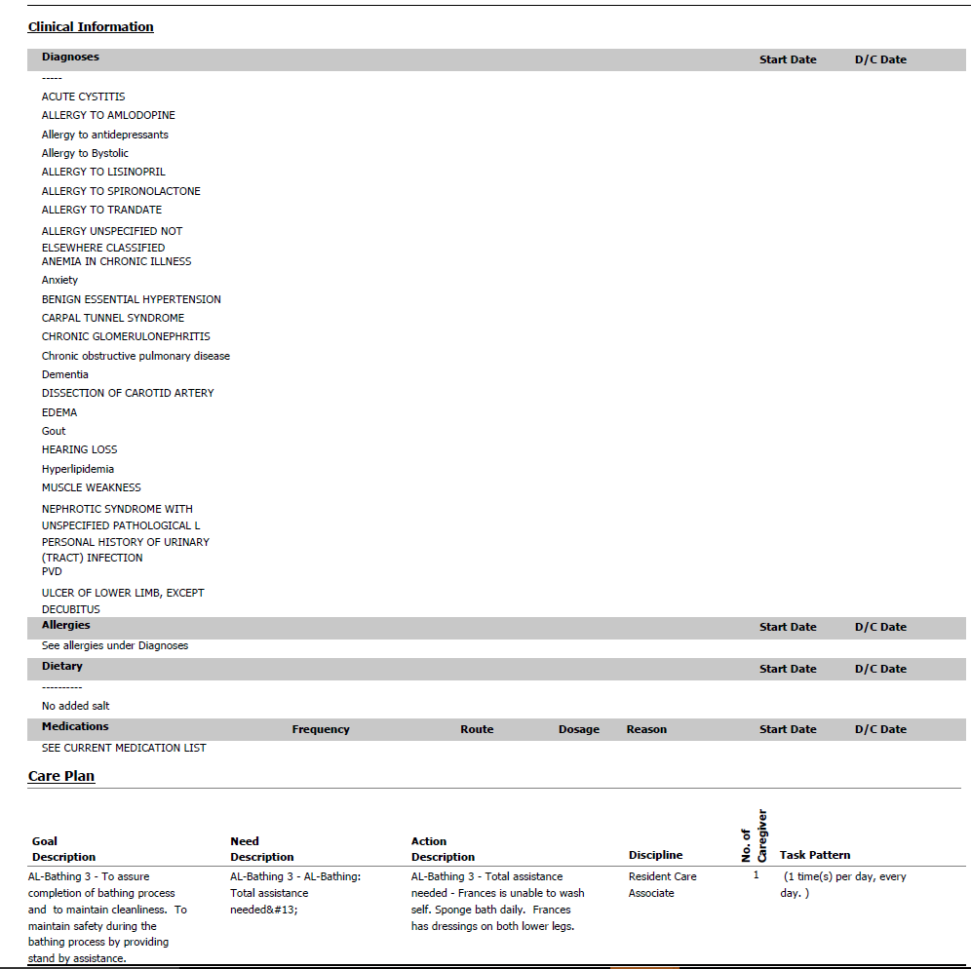
SAMPLE SERVICE PROGRAM
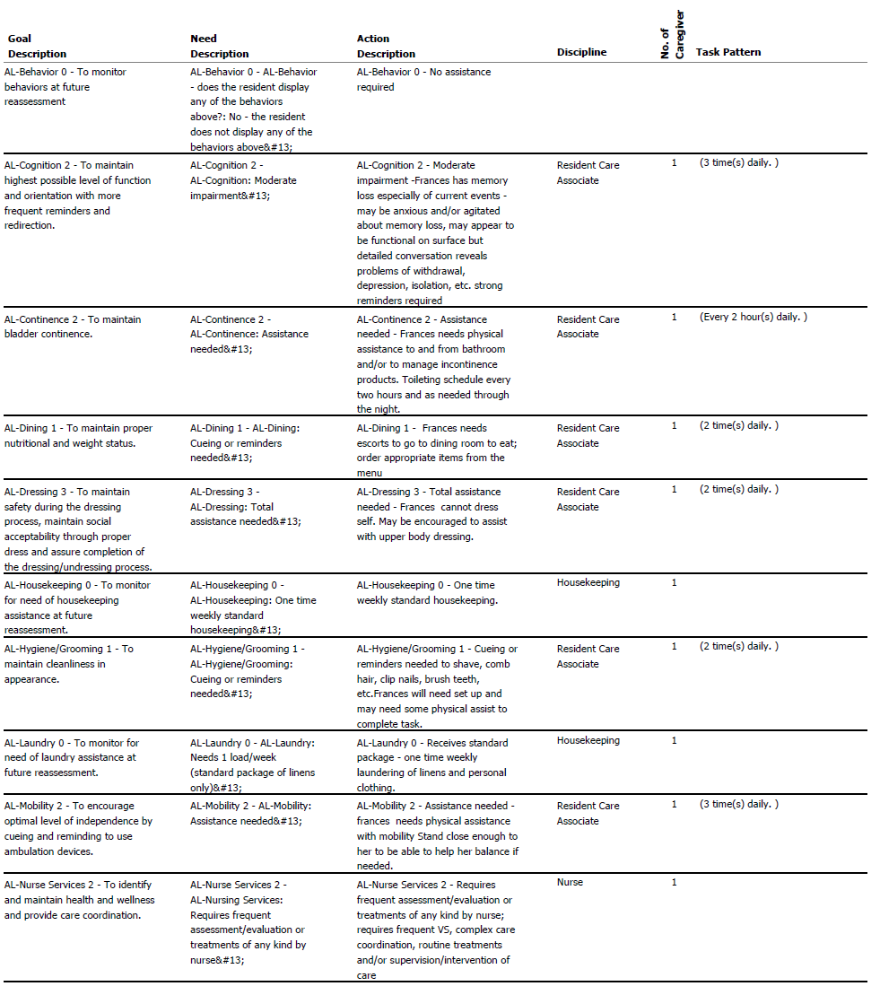

SAMPLE SERVICE PROGRAM
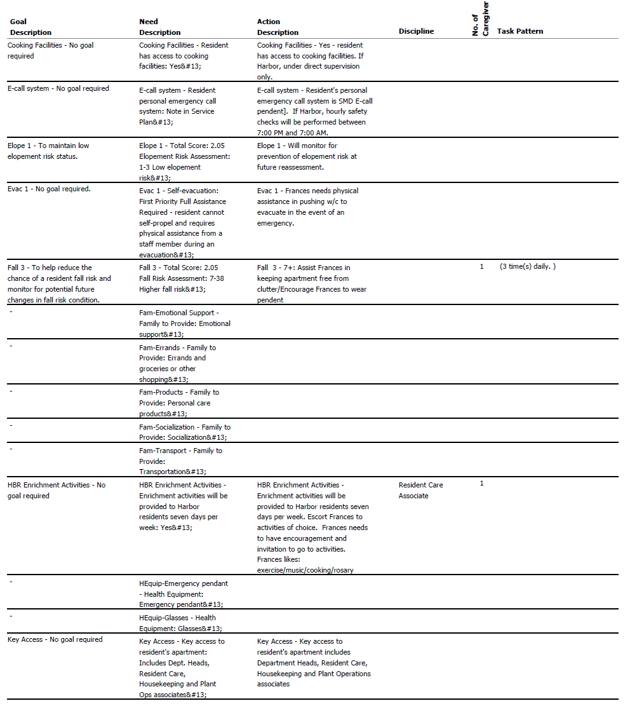

SAMPLE SERVICE PROGRAM
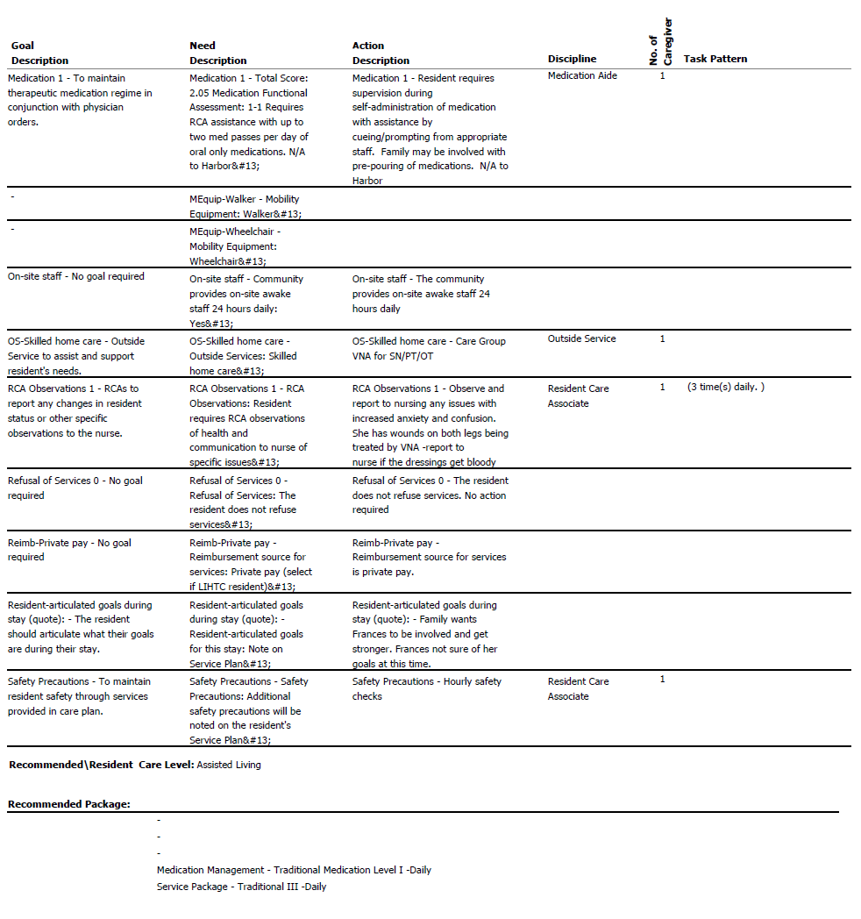

The Legal Representative is a person authorized by the Resident and/or applicable law to make health care and contract decisions on the Resident’s behalf in connection with his or her residency at the Community. The Resident must have a Legal Representative if the Resident does not wish to, or is not capable of making, health care or contracting decisions on his or her own behalf.

